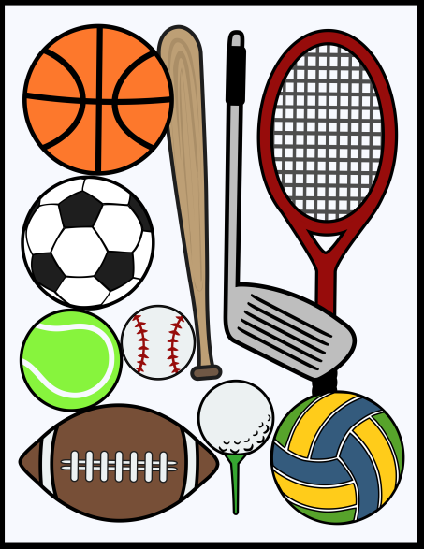

- I _______________ hockey every weekend.
- I _______________judo once a week.
- I _______________skiing every winter.

Rule:
GO +________________________________________________
DO + ________________________________________________
PLAY + ______________________________________________

- I _______________ hockey every weekend.
- I _______________judo once a week.
- I _______________skiing every winter.

Rule:
GO +________________________________________________
DO + ________________________________________________
PLAY + ______________________________________________

